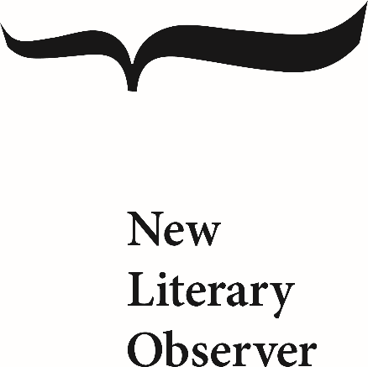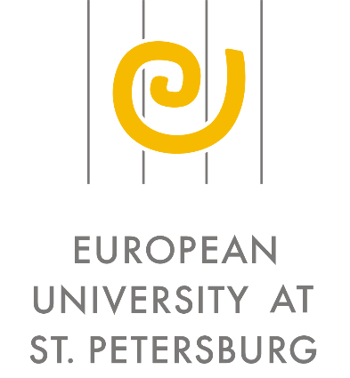

The "New Literary Observer" journal and the European University at St. Petersburg are pleased to announce a call for papers for the second conference within the framework of their joint program *"The Anthropological Turn in the Humanities and Social Sciences*".

DIGNITY AS A HISTORICAL CONCEPT AND AS A KEY CATEGORY OF OUR TIME

Moscow, June 2-4, 2017

Кeynote speaker: **Professor Homi Bhabha**

Director of Mahindra Humanities Center at Harvard University

Appealing to dignity as a serious argument in public debate has become a hallmark of modern international public discourse. For example, politicians routinely speak about the dignity and/or humiliation of a country or state. Suffice it to recall the rhetoric of Russia "getting up off its knees" or Donald Trump's calls to restore the dignity and greatness of America. Furthermore, some social groups are even more likely to refer to the humiliation of human dignity, as illustrated by the protesting "angry urbanites" in Russia in late 2011– early 2012, as well as all kinds of "offended believers", and demonstrations against anti-immigrant xenophobia, to list but a few examples.

More than 20 years ago, the Israeli philosopher Avishai Margalit wrote a book dedicated to philosophical reflections on the concepts of dignity, honor, and humiliation in contemporary collective and individual consciousness (Avishai Margalit, *The Decent Society*, 1995). Since then, the global academic literature (primarily in English) has witnessed a sharp increase in research on dignity, which demonstrates the significance of the concept for explaining fundamental social transformation and the critical points of the modern era.

The concept of dignity has also become an important object in the analysis of Western thought with regards to historical perspectives. Essentially, it is the evolution of perceptions about the personal, corporate, state, and/or national dignity under the influence of various sociocultural factors that often led to shifting civilizational paradigms.

We suggest that the participants of the conference discuss the concept of dignity (and the related categories of honor, valor, humiliation, desecration, etc.) as a historical category and as an underlying factor of social contention in the modern world.

The organizers of the conference would like to approach the problematization of the historical concept of dignity from various points of view: philosophical, cultural, linguistic (including the legacy of the classical languages), political, and social.

Applications for participation with a short CV should be sent to sasha.volodina@gmail.com no later than March 31, 2017.

The organizing committee reserves the right to select the applications received. Travel grants and accommodation in Moscow will be available for participants.

**THE ORGANIZERS:**

NEW LITERARY OBSERVER (launched in 1992 by a cultural historian Irina Prokhorova) is the leading Russian intellectual center and publishing house studying Russian literature, history and culture in a global context as well as promoting contemporary Russian thought in the international academic community. At present NLO comprises 3 scholarly periodicals, 2 annual conferences, a variety of educational and intellectual projects, and over 80 books per year on literary criticism, philosophy, history, cultural and interdisciplinary studies, contemporary prose and poetry.

The main task of NLO is to seek and stimulate new approaches to studying human nature and culture, to reflect on the new challenges and rapidly changing status of academic institutions with the final aim of radically modernizing the field of human studies. The NLO authors are major international experts from almost all areas of humanities: history, philosophy, cultural studies, sociology, literary criticism, and cultural and historical anthropology.

EUROPEAN UNIVERSITY AT ST.PETERSBURG. Founded in 1994 with the active support of the city of St. Petersburg, the European University began operating as an elite graduate school in the social sciences and humanities in 1996. From its inception, the mission of EUSP has been to meet the needs of Russian social development by training a new generation of teachers and scholars in the best Russian and Western traditions.  The European University is one of only a few non-state universities fully qualified by the Ministry of Education to award advanced graduate degrees. Over some 20 years, EUSP has gained an international reputation for the superb scholarship of its faculty and the training of Russia's best and brightest graduate students.