First Announcement

13th Biennial International Conference

Advanced Carbon NanoStructures

(ACNS’2017)

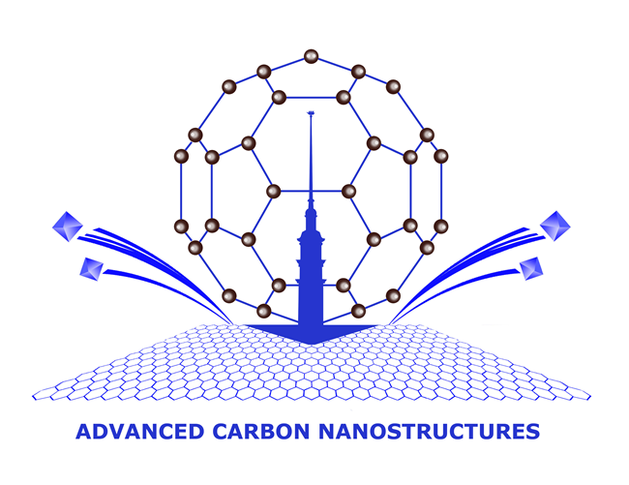

July 3 - 7, 2017

St.Petersburg, Russia

Abstracts deadline – 20 March, 2017

Organizers

Ioffe Physico-Technical Institute, Russia

Petersburg Nuclear Physics Institute, Russia

National Research Center "Kurchatov Institute", Russia

St.Petersburg State Institute of Technology (Technical University), Russia

Scope
The program will traditionally include lectures by invited speakers, oral presentations and several poster sessions. The lectures and oral presentations will generally concentrate on the most recent advances in the following areas:

- Materials

  - Fullerenes

Carbon Nanotubes

Graphene
  - Nanodiamond particles
  - Carbon onions
  - Nanographite
  - Nanoporous carbon

- Phenomena

  - Synthesis
  - Electronic properties
  - Magnetic properties
  - Optical properties
  - Mechanical properties
  - Phase transitions

And

- Technology of all materials mentioned above
- Theory and computer simulation of carbon nanostrucrtures
- Methods for characterization of nanocarbons
- Applications of carbon nanostructures
Preliminary list of invited speakers

1. Florian Banhart, Strasbourg University, France
Chains of carbon atoms as elements of sp1-hybridized carbon

2. Petr Cigler, Institute of Organic Chemistry and Biochemistry AS CR, Czech Republic
Chemical approaches to controlling diamond nanointerface for imaging and sensing in biological environment

3. Hugues A. Girard, CEA LIST, France

4. Fedor Jelezko, Ulm University, Germany

5. Esko Kauppinen, Aalto University, Finland

6. Arkady Krasheninnikov, Helmholtz-Center, Germany and Aalto University, Finland
Defects in two-dimensional inorganic materials

7. Tomoki Machida, University of Tokyo, Japan
Quantum transport in van der Waals junctions of graphene and 2D materials

8. Vadym Mochalin, Missouri University of Science&Technology, USA

9. Alexander Okotrub, Institute of Inorganic Chemistry, Russia

10. Alexander Panich, Ben-Gurion University of the Negev, Israel
Nuclear Magnetic Resonance Studies of Nanodiamond Surface Modification

11. Alexey Popov, Leibniz Institute for Solid State and Materials Research, Germany
Interior design of metallofullerenes for single molecular magnetism

12. Francois Treussart, Laboratoire Aime Cotton, CNRS UPR 3321, France
Some biomedical applications of fluorescent nanodiamonds

Organizing Committee of ACNS’20177

Ioffe Institute
26 Polytechnicheskaya st.
St.Petersburg 194021, Russia
Tel: +7(812) 292 73 77; Fax: +7(812) 297 00 73
e-mail: info@acns2017.org
www.acns2017.org
INFORMATION

Biennial International conference "Advanced Carbon Nanostructures" ACNS’2017 the same as ACNS’2013 continues the series of the joined conferences that started in 2011 when the 10th Biennial International Workshops "Fullerenes and Atomic Clusters" and the 4th International Symposiums "Detonation Nanodiamonds: Technology, Properties and Applications" were unified into single event "Advanced Carbon Nanostructures 2011" (ACN’2011).

The scope of the conference includes new carbon nanostructures, members of nanocarbon family - fullerenes, carbon nanotubes, graphene, carbide derived carbon, onions, nanographite and nanodiamonds.

ACNS'2017 is the international forum for the exchange of information on the latest progress in carbon nanostructures. The scientific program consists of both oral and poster presentations as well as lectures by invited keynote speakers who survey areas of major interest.
General topics include synthesis and technology, physical properties, chemistry of carbon nanostructures as well as their main applications for industry, biology and medicine.

Progress in modern nanotechnologies requires development of new, and refinement of already available methods of diagnostics. This is why we also arrange the conference school for young scientists "Advanced carbon nanostructures and methods of their diagnostics" which will be held in the frame of the ACNS'2017.

St Petersburg is both a scientific and a cultural center. It is a beautiful city designed and built by Russian and Western architects. It is often called "the Venice of the North". As usual along with the Scientific Session, a Social Program is planned.

The Organizers are pleased to welcome members of the world nanocarbon community to St Petersburg during the beautiful time of white nights.

Organizing committee
Alexander Ya. Vul' - (Chair), Ioffe Institute, Russia
Irina Vorobyova- (Secretary), Ioffe Institute, Russia
B.B. Chaivanov - National Research Center "Kurchatov Institute", Russia
I.L. Eremenko - Kurnakov Institute of General and Inorganic Chemistry, Russia
V.F. Ezhov - National Research Centre "Kurchatov Institute", Petersburg Nuclear Physics Institute, Russia
P.S. Kop'ev - Ioffe Institute, Russia
V.V. Kveder - Institute of Solid State Physics, Russia
M.Yu. Romanovsky - Department of General Physics, Russian Academy of Science
A.P. Shevchik - St Petersburg State Institute of Technology, Russia
S.A. Tsyganov - Russian Foundation for Basic Research, Russia
A.G. Zabrodsky - Ioffe Institute, Russia

International Advisory Committee
F. Banhart Strasbourg University, France
F. Cataldo University of Rome Tor Vergata, Italy
J. Davidson Vanderbilt University, USA
M. Dresselhaus MIT, USA
L. Echegoyen University of Texas at El Paso, USA
T. Enoki Tokyo Institute of Technology, Japan
D. Gruen Argonne National Laboratory, USA
D. Guldi University of Erlangen-Nurnberg, Germany
M. Heggie University of Surrey, UK
R. Kalish Israel Institute of Technology, Israel
W. Kraetschmer Max-Plank Institute, Germany
H. Kroto Florida State University, USA
E. Osawa Nanocarbon Research Institute Ltd, Japan
H. Shinohara Nagoya University, Japan
F. Wudl University of California, USA
Program Committee

Artur T. Dideikin - (Chair), Ioffe Institute, Russia
Alexander Meilakhs - (Secretary), Ioffe Institute, Russia
V.L. Aksenov - National Research Centre "Kurchatov Institute", Petersburg Nuclear Physics Institute, Russia
A.E. Aleksensky - Ioffe Institute, Russia
A.S. Artjomov - General Physics Institute, Russia
M. V. Baidakova - Ioffe Institute, Russia
V.Yu. Dolmatov - Federal State Unitary Enterprise "Special Design and Technological Office "Technolog",
Russia
A.V. Eletskii - National Research Centre "Kurchatov Institute", Russia
M. Korobov - Moscow State University, Russia
S.V. Kozyrev - Center for Advanced Studies of Peter the Great St.Petersburg Polytechnic University, Russia
A.V. Krestinin - Institute of Problems of Chemical Physics, Russia
I.I. Kulakova - Moscow State University, Moscow, Russia
V.L. Kuznetsov - Boreskov Institute of Catalysis, Russia
L.B. Piotrovsky - Institute of Experimental Medicine, Russia
O.A. Shenderova - International Technology Center, USA
A.M. Shikin - St Petersburg State University, Russia
V.I. Sokolov - Institute of Organoelement Compounds, Russia,
V.M. Titov - Institute for Hydrodynamics, Russia
A.P. Vozniakovskii - Federal State Unitary Enterprise Scientific Research Institute for Synthetic Rubber, Russia
A.Ya.Vul’ - Ioffe Institute, Russia

